**DOCKER IMAGES CREATED**

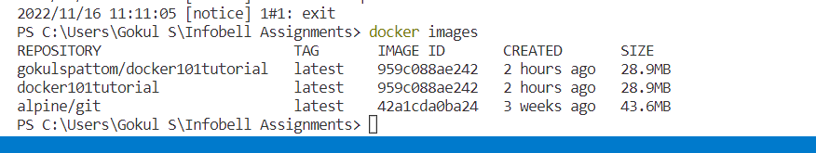

**DOCKER CONTAINER VIEWING**

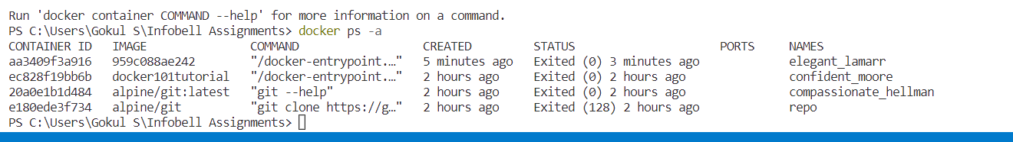

**DOCKER IMAGE PUSHED INTO DOCHUB**

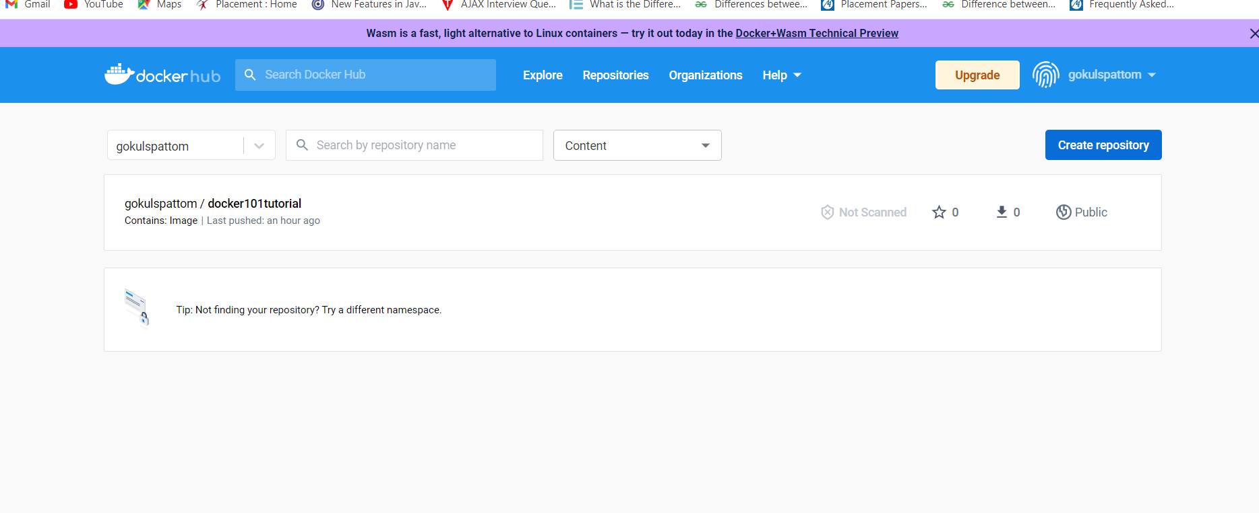

**LOGS OF RUNNING THE IMAGE**

